i i i i i i i i i i i i i i i i i i i i i i i i i i i i i i i i i i i i i i i i i i i i i i i i i i i i i i i i i i i i i i i i i i i i i i i i i i i i i i i i i

**A iPROJECT iREPORT iON**

**Stock iTrend iPrediction**

**Submitted iby**

# Mr. iANIKET iSHARMA

**Under ithe iguidance iof**

# Ms. iJYOTI iYADAV

**Submitted iin ipartial ifulfilment iof ithe irequirements ifor iqualifying iB.Sc. i(CS), iSemester i– iVI iExamination**

**i i i i i i i i i i i i i i i i i i i i i i i i i i i i iACADEMIC iYEAR i2021-2022**

**i i i iORIENTAL iEDUCATION iSOCIETY’S iSANPADA i i i i i i i i i i i i i i i i i i i i i i i i i i i i i i i i i i i i i i i I i i iCOLLEGE iOF iCOMMERCE i& iTECHNOLOGY**

**Sanpada i(W) i– i400705, iNavi iMumbai.**



**SANPADA iCOLLEGE iOF iCOMMERCE i& iTECHNOLOGY**

**CERTIFICATE**

**This iis ito iCertify ithat ithe iProject iEntitled i“Stock iTrend iPrediction” I undertaken iat I the iSanpada iCollege iof iCommerce i& iTechnology iby i“Mr. iAniket isharma”, iSeat ino.38 iin ipartial ifulfilment iof iB.Sc. i(CS) iDegree i(Semester i– iVI) iExamination ihas inot ibeen isubmitted ifor iany iother iExamination iand idoes inot iform ipart iof iany iother icourse iundergone iby ithe icandidate.It iis ifurther icertified ithat ihe ihas icompleted iall irequired iphases iof ithe iproject.**

**Signature iof iInternal iGuide Signature iof iExternal iExaminer**

**Signature iof iHOD Signature iof iPrincipal**

**College iSeal**

**ACKNOWLEDGEMENT**

I iwould ilike ito iacknowledge iand iextend imy iheartfelt igratitude ito ithe ifollowing ipeople iwho ihave iguided ime ithroughout ithe ijourney iof imy iproject. iI iwould ialso iinclude iextension iof imy iheartfelt igratitude iand ithanks ito i**Prof. iJyoti iYadav i**for iproviding ime iexcellent iguidance ito iwork ion ithis iproject iand ifor ihelping ime iout ithrough ieach iand ievery iquery, iAlong iwith ithat, iI iwould ialso ilike ito ithank imy iparents i& ifriends i( iRashmi iand iHemant) iwhole iheartedly ifor ifinalizing ithis iproject iwithin ia ilimited itime iframe. iAnd ialso ifor iproviding imutual iunderstanding iand iassistance ifor igiving iall ithe inecessary iinformation ineeded ifor icompleting ithe iproject.

I iwould ialso ilike ito iacknowledge iall ithe ilibrary istaff ifor iproviding ime iquality itime iand ia igreat ihand-in isupport iat itimes iof iqueries iand iproblems. iThe iProject iis ia iresult iof iall imy iefforts iand iof ithe ipeople iwho iare iassociated iwith ithe iproject idirectly ior iindirectly, iwho ihelped ime ithrough imy icompletion ijourney ifor ithe iproject iwithin ithe ispecified itime.

I igot ito ilearn ia ilot ifrom ithis iproject iabout i(new iconcepts iand ithe iback-end ilogic irequired ifor ibooking isystem). iI iwould ialso ilike ito ithank iour iPrincipal iSir i**Prof. iRaosaheb i**for iproviding ihis icontinued iand iunending isupport. iI ialso iwant ito ithank i**Prof. iSmita iNegi**, iHead iof iComputer iScience iDepartment ifor igranting ime ipermission ito iwork ion ithis iProject. iI iwish ito iexpress iour igratitude ito iall ifaculties iof iComputer iScience iDepartment ifor itheir ico-operative iand iconsiderate iapproach.

Student’s iSignature,

**Aniket iSharma**

**iTY iB.Sc. i(CS)**

**PLAGIARISM iREPORT**

perform our code and because of runn ng of tensor flow n background w ll make our

faced n stock market analys s. 3. REQU REMENT F rst of all, we need a strong system to

d str buted, parallel zed fash on. These are some of the cons derat ons and challenges

pred ct ons made; as such, most stock pred ct on systems are mplemented n a

every m nute, there comes a trade-off between the accuracy and the volume of

Due to the sheer volume of money nvolved and number of transact ons that take place

poss ble to make an educated est mate of pr ces. Stock prs of many stocks at once.

the volat l ty of factors that play a major role n the movement of pr ces. However, t s

about the stock market. t s near mposs ble to pred ct stock pr ces to the T, ow ng to

(`Volume'). Econom cs and stock pr ces are ma nly rel ant upon subject ve percept ons

Exper mental Results 29 8 Conclus on 30 se. Stock markets are ded dur ng the day

Requ rement Spec f cat on 7 4 Methodology 9 5 Analys s 16 6 Exper mental Work 19 7

PLAG AR SM REPORT NDEX Sr.no. Top c Page no. 1 Stock Trend Pred ct on 5 2 ntroduct on 6 3

on th s Project. w shns derate approach. Student’s S gnature, An ket Sharma TY B.Sc. (CS)

would l ke to aead of Computer Sc ence Department for grant ng me perm ss on to work

External Exam ner S gnature of HOD S gnature of Pr nc pal College Seal ACKNOWLEDGEMENT

completed all requ red phases of the project. S gnature of nternal Gu de S gnature of

part of any other course undergone by the cand date. t s further cert f ed that he has

V ) Exam nat on has not been subm tted for any other Exam nat on and does not form

“Mr. An ket sharma”, Seat no. “38” n part al fulf lment of B.Sc. (CS) Degree (Semester –

Trend Pred ct on” undertaken at the Sanpada College of Commerce & Technology by

COMMERCE & TECHNOLOGY CERT F CATE Th s s to Cert fy that the Project Ent tled “Stock

COMMERCE & TECHNOLOGY Sanpada (W) – 400705, Nav Mumba . SANPADA COLLEGE OF

ACADEM C YEAR 2021-2022 OR ENTAL EDUCAT ON SOC ETY’S SANPADA COLLEGE OF

requ rements for qual fy ng B.Sc. (CS), Semester – V Exam nat on

SHARMA Under the gu dance of Ms. JYOT YADAV Subm tted n part al fulf lment of the

A PROJECT REPORT ON Stock Trend Pred ct on Subm tted by Mr. AN KET

Content Checked For Plag ar sm

Exclude URL

None

Plag ar sed

Un que

0%

100%

Characters

5754

Words

803 / 1000

Plag ar sm Scan Report

Words Stat st cs

Date: March, 13 2022

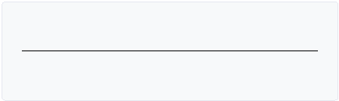

Copyr ght © 2022 Plag ar sm Detector. All r ght reserved

Home

Blog

Test mon als

About Us

Pr vacy

code error www.geeksforgeeks.com for data www.yahoof nance.com 19

Conclus on The References https://www.youtube.com/watch?v=s3CnE2tqQdo www. jsr.net for

load_model mport streaml t as st s #c sual zat ons st.subheader('Clos ng pr ce vs T m 8.

matplotl b.pyplot as plt mport pandas_datareader as data from keras.models mport

Pred cted graph After p Codes mport numpy as np mport pandas as pd mport

Results Data fetch ng us ng yahoo f nance L ve Data graph Gr Scal ng the data n array

samples for tra n ng purpose and 132 samples for val dat on purpose. ● 7. Exper mental

got 1312 sequences from 01.01.2011 to 31.12.2016. From these data set we used 1180

w ndow s ze of 22 days. Data ranges from 01.01.2011 to 31.12.2016. ● Sequence data: We

50 from the Nat onal stock exchange. We have collected da ly dataset and kept a

data from https://www.quandl.com. We have collected the h stor cal stock data of N FTY

act vat on funct on. 5.Analys s 6. Exper mental Work Dataset descr pt on: We acqu red the

dense layer w th ReLU act vat on and then f nally a dense output layer w th l near

LSTM model s composed of a sequent al nput layer followed by 2 LSTM layers and

neural network and tra ned for pred ct on ass gn ng random b ases and we ghts. Our

and volume. · Stage 4: Tra n ng Neural Network: n th s stage, the data s fed to the

neural network are chosen. We w ll choose the feature from Date, open, h gh, low, close,

Stage 3: Feature Extract on: n th s layer, only the features wh ch are to be fed to the

the more recent values. Test ng data s kept as 5-10 percent of the total dataset. ·

stage nvolves a) Data d scret zat on: Part of data reduct ontra n ng values are taken as

the pred ct on of future stock pr ces. · Stage 2: Data Preprocess ng: The pre-process ng

h stor cal stock data s collected from yahoo f nance and th s h stor cal data s used for

method etc. For th s exper ment, we have cons dered Recurrent Neural Network and Lo

be developed by the comb nat on of d fferent factors l ke network topology, tra n ng

nternet for fetch ng onl ne l ve data 4. Methodology Var ous types of neural networks can

w th latest vers on 3. Ram 8gb for smooth work 4. 256 gb storage for extract on of data 5.

l ne eas ly. Requ rement as follows. 1. W ndows 10 or upper vers on 2. Anaconda software

appl cat on so t w ll help to run code l ne by l ne and we w ll able to f nd error l ne by

system slow and then we must check out nternal storage to nstall anaconda



**INDEX**

|  |  |  |
| --- | --- | --- |
| **Sr.no.** | **Topic** | **Page ino.** |
| 1 | Stock iTrend iPrediction | 7 |
| 2 | Introduction | 8 |
| 3 | Requirement iSpecification | 9 |
| 4 | iMethodology | 10 |
| 5 | iAnalysis | 12 |
| 6 | iExperimental iWork | 13 |
| 7 | iExperimental iResults | 14 |
| 8 | Conclusion | 18 |

**1.STOCK iTREND iPREDICTION i**

Predicting istock imarket iprices iis ia icomplex itask ithat itraditionally iinvolves iextensive ihuman-computer iinteraction. iDue ito ithe icorrelated inature iof istock iprices, iconventional ibatch iprocessing imethods icannot ibe iutilized iefficiently ifor istock imarket ianalysis. iWe ipropose ian ionline ilearning ialgorithm ithat iutilizes ia ikind iof irecurrent ineural inetwork i(RNN) icalled iLong iShort iTerm iMemory i(LSTM), iwhere ithe iweights iare iadjusted ifor iindividual idata ipoints iusing istochastic igradient idescent. iThis iwill iprovide imore iaccurate iresults iwhen icompared ito iexisting istock iprice iprediction ialgorithms. iThe inetwork iis itrained iand ievaluated ifor iaccuracy iwith ivarious isizes iof idata, iand ithe iresults iare itabulated. iA icomparison iwith irespect ito iaccuracy iis ithen iperformed iagainst ian iArtificial iNeural iNetwork. i i

The iinitial ifocus iof iour iliterature isurvey iwas ito iexplore igeneric ionline ilearning ialgorithms iand isee iif ithey icould ibe iadapted ito iour iuse icase ii.e., iworking ion ireal-time istock iprice idata. i

These iincluded iOnline iAUC iMaximization, iOnline iTransfer iLearning, iand iOnline iFeature iSelection. iHowever, ias iwe iwere iunable ito ifind iany ipotential iadaptation iof ithese ifor istock iprice iprediction, iwe ithen idecided ito ilook iat ithe iexisting isystems, ianalyze ithe imajor idrawbacks iof ithe isame, iand isee iif iwe icould iimprove iupon ithem. i

We izeroed iin ion ithe icorrelation ibetween istock idata i(in ithe iform iof idynamic, ilong-term itemporal idependencies ibetween istock iprices) ias ithe ikey iissue ithat iwe iwished ito isolve. i

A ibrief isearch iof igeneric isolutions ito ithe iabove iproblem iled ius ito iRNN’s iand iLSTM. iAfter ideciding ito iuse ian iLSTM ineural inetwork ito iperform istock iprediction, iwe iconsulted ia inumber iof ipapers ito istudy ithe iconcept iof igradient idescent iand iits ivarious itypes

. i

We iconcluded iour iliterature isurvey iby ilooking iat ihow igradient idescent ican ibe iused ito itune ithe iweights iof ian iLSTM inetwork iand ihow ithis iprocess ican ibe ioptimized.

**2. iINTRODUCTION**

The istock imarket iis ia ivast iarray iof iinvestors iand itraders iwho ibuy iand isell istock, ipushing ithe iprice iup ior idown. iThe iprices iof istocks iare igoverned iby ithe iprinciples iof idemand iand isupply, iand ithe iultimate igoal iof ibuying ishares iis ito imake imoney iby ibuying istocks iin icompanies iwhose iperceived ivalue iis iexpected ito irise. i

Stock imarkets iare iclosely ilinked iwith ithe iworld iof ieconomics i—the irise iand ifall iof ishare iprices ican ibe itraced iback ito isome iKey iPerformance iIndicators. iThe ifive imost icommonly iused iKPI's iare ithe iopening istock iprice i(`Open'), iend-of-day iprice i(`Close'), iintraday ilow iprice i(`Low'), iintra-day ipeak iprice i(`High'), iand itotal ivolume iof istocks itraded iduring ithe iday i(`Volume').

iEconomics iand istock iprices iare imainly ireliant iupon isubjective iperceptions iabout ithe istock imarket. iIt iis inear iimpossible ito ipredict istock iprices ito ithe iT, iowing ito ithe ivolatility iof ifactors ithat iplay ia imajor irole iin ithe imovement iof iprices. iHowever, iit iis ipossible ito imake ian ieducated iestimate iof iprices.

iStock iprices inever ivary iin iisolation: ithe imovement iof ione itends ito ihave ian iavalanche ieffect ion iseveral iother istocks ias iwell. iThis iaspect iof istock iprice imovement ican ibe iused ias ian iimportant itool ito ipredict ithe iprices iof imany istocks iat ionce. i

Due ito ithe isheer ivolume iof imoney iinvolved iand inumber iof itransactions ithat itake iplace ievery iminute, ithere icomes ia itrade-off ibetween ithe iaccuracy iand ithe ivolume iof ipredictions imade; ias isuch, imost istock iprediction isystems iare iimplemented iin ia idistributed, iparallelized ifashion. i

These iare isome iof ithe iconsiderations iand ichallenges ifaced iin istock imarket ianalysis.

**3. iREQUIREMENT i**

First iof iall, iwe ineed ia istrong isystem ito iperform iour icode iand ibecause iof irunning iof itensor iflow iin ibackground iwill imake iour isystem islow iand ithen iwe imust icheck iout iinternal istorage ito iinstall ianaconda iapplication iso iit iwill ihelp ito irun icode iline iby iline iand iwe iwill iable ito ifind ierror iline iby iline ieasily.

Requirement ias ifollows.

1. Windows i10 ior iupper iversion
2. Anaconda isoftware iwith ilatest iversion
3. Ram i8gb ifor ismooth iwork
4. 256 igb istorage ifor iextraction iof idata
5. Internet ifor ifetching ionline ilive idata

4. i**Methodology**

Various itypes iof ineural inetworks ican ibe ideveloped iby ithe icombination iof idifferent ifactors ilike inetwork itopology, itraining imethod ietc. iFor ithis iexperiment, iwe ihave iconsidered iRecurrent iNeural iNetwork iand iLong iShort-Term iMemory. iThis isection iwe iwill idiscuss ithe imethodology iof iour isystem. iOur isystem iconsists iof iseveral istages iwhich iare ias ifollows: i-

• iStage i1: iRaw iData: iIn ithis istage, ithe ihistorical istock idata iis icollected ifrom iyahoo ifinance iand ithis ihistorical idata iis iused ifor ithe iprediction iof ifuture istock iprices.

i• iStage i2: iData iPreprocessing: iThe ipre-processing istage iinvolves ia) iData idiscretization: iPart iof idata ireduction ibut iwith iparticular iimportance, iespecially ifor inumerical idata ib) iData itransformation: iNormalization. ic) iData icleaning: iFill iin imissing ivalues. id) iData iintegration: iIntegration iof idata ifiles. iAfter ithe idataset iis itransformed iinto ia iclean idataset, ithe idataset iis idivided iinto itraining iand itesting isets iso ias ito ievaluate. iHere, ithe itraining ivalues iare itaken ias ithe imore irecent ivalues. iTesting idata iis ikept ias i5-10 ipercent iof ithe itotal idataset. i

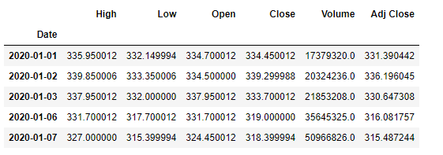

• iStage i3: iFeature iExtraction: iIn ithis ilayer, ionly ithe ifeatures iwhich iare ito ibe ifed ito ithe ineural inetwork iare ichosen. iWe iwill ichoose ithe ifeature ifrom iDate, iopen, ihigh, ilow, iclose, iand ivolume. i

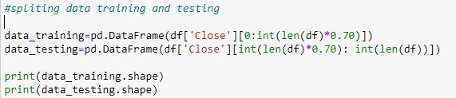

• iStage i4: iTraining iNeural iNetwork: iIn ithis istage, ithe idata iis ifed ito ithe ineural inetwork iand itrained ifor iprediction iassigning irandom ibiases iand iweights. iOur iLSTM imodel iis icomposed iof ia isequential iinput ilayer ifollowed iby i2 iLSTM ilayers iand idense ilayer iwith iReLU iactivation iand ithen ifinally ia idense ioutput ilayer iwith ilinear iactivation ifunction.

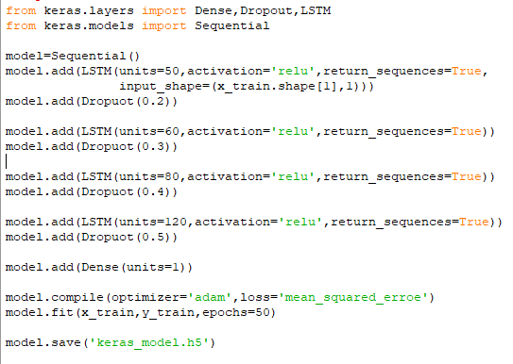

• iStage i5: iOutput iGeneration: iIn ithis ilayer, ithe ioutput ivalue igenerated iby ithe ioutput ilayer iof ithe iRNN iis icompared iwith ithe itarget ivalue. iThe ierror ior ithe idifference ibetween ithe itarget iand ithe iobtained ioutput ivalue iis iminimized iby iusing iback ipropagation ialgorithm iwhich iadjusts ithe iweights iand ithe ibiases iof ithe inetwork.

**5.Analysis**

For ianalyzing ithe iefficiency iof ithe isystem iwe iare iused ithe iRoot iMean iSquare iError(RMSE). iThe ierror ior ithe idifference ibetween ithe itarget iand ithe iobtained ioutput ivalue iis iminimized iby iusing iRMSE ivalue. iRMSE iis ithe isquare iroot iof ithe imean/average iof ithe isquare iof iall iof ithe ierror. iThe iuse iof iRMSE iis ihighly icommon iand iit imakes ian iexcellent igeneral ipurpose ierror imetric ifor inumerical ipredictions. iCompared ito ithe isimilar iMean iSquared iError, iRMSE iamplifies iand iseverely ipunishes ilarge ierrors.

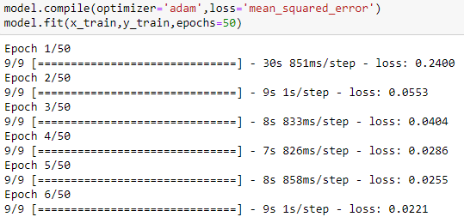

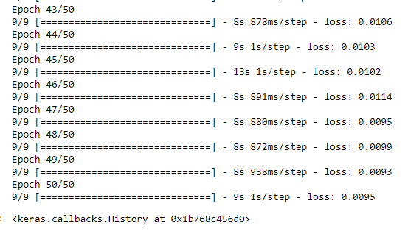

6. i**Experimental iWork**

Dataset idescription: iWe iacquired ithe idata ifrom ihttps://www.quandl.com. iWe ihave icollected ithe ihistorical istock idata iof iNIFTY i50 ifrom ithe iNational istock iexchange. iWe ihave icollected idaily idataset iand ikept ia iwindow isize iof i22 idays. iData iranges ifrom i01.01.2011 ito i31.12.2016.

● iSequence idata: iWe igot i1312 isequences ifrom i01.01.2011 ito i31.12.2016. iFrom ithese idata iset iwe iused i1180 isamples ifor itraining ipurpose iand i132 isamples ifor ivalidation ipurpose.

i

● iTraining iDetail: iFor itraining ithe imodel iwe iused iRMSprop ias ithe ioptimizer iand inormalized ieach ivector iof ithe isequence. iWe iused iGoogle icloud iengine ias ia itraining iplatform i[Machine itype: in1-standard-2 i(2 ivCPUs, i7.5 iGB imemory), iCPU iplatform: iIntel iIvy iBridge] iand iused iWindows i10, iKeras i(Frontend) iand iTensorflow i(Backend) ias ithe ilearning ienvironment. iFor iour iexperiment, iwe ihave iused ia ivarious iset iof iparameters iwith ia idifferent inumber iof iepochs ito imeasure ithe iRMSE iof iTraining iand iTesting idataset.

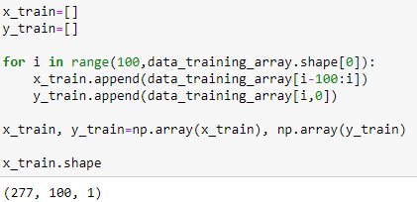

**7**. **iExperimental iResults**

**Data ifetching iusing iyahoo ifinance**



**Live iData igraph i**

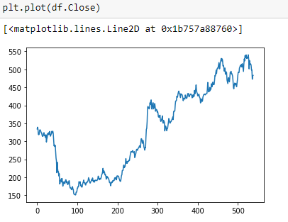

**Graph iwith i50 iMA ifor itrend i**

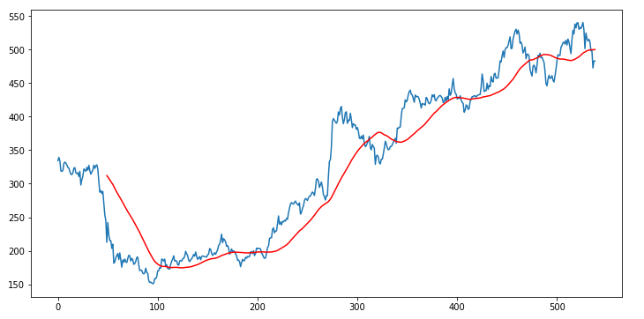

**Graph iwith i100 iMA ifor itrend i**

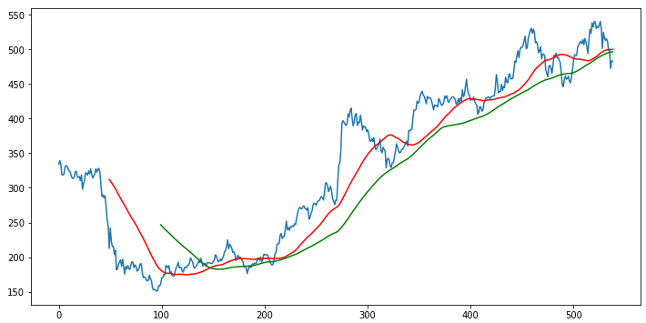

**Scaling ithe idata iin iarray**

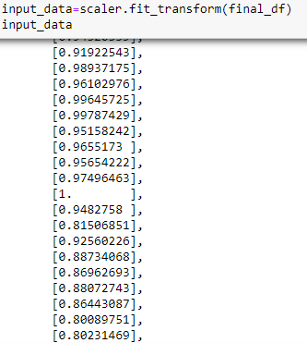

**Predicted igraph**

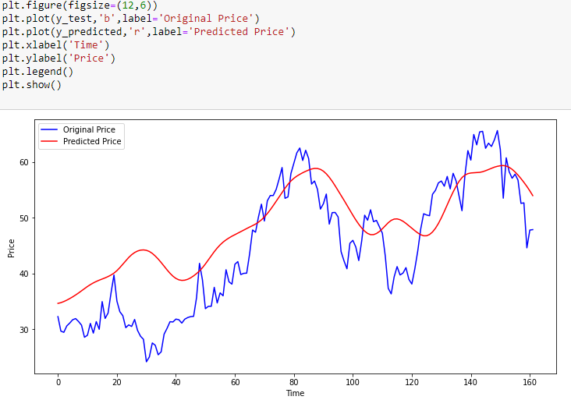

After iperforming ivarious isimulations iwith ia idifferent inumber iof iparameters iand iepochs, iwe ihave iobserved ithat iby itaking i4 ifeatures iset i(High/Low/Open/ iClose) iwith i50 iepochs iwe iachieve ithe ibest iresults iwith itesting iRMSE iof i0.00472367.

**Codes**

import inumpy ias inp

import ipandas ias ipd

import imatplotlib.pyplot ias iplt

import ipandas_datareader ias idata

from ikeras.models iimport iload_model

import istreamlit ias ist

start i= i'2020-01-01'

end i= i'2022-02-28'

st.title('Stock iTrend iPrediction')

user_input=st.text_input('Enter istock iticker','APPL')

df=data.DataReader(user_input,'yahoo',start,end)

#descriding idata

st.subheader('Data ifrom i2020-2022')

st.write(df.describe())

#cisualizations

st.subheader('Closing iprice ivs iTime ichart')

fig=plt.figure(figsize=(12,6))

plt.plot(df.Close)

st.pyplot(fig)

st.subheader('Closing iprice ivs iTime ichart iwith i50 ima')

ma50=df.Close.rolling(50).mean()

fig=plt.figure(figsize=(12,6))

plt.plot(ma50)

plt.plot(df.Close)

st.pyplot(fig)

st.subheader('Closing iprice ivs iTime ichart iwith i50ma i& i100ma')

ma50=df.Close.rolling(50).mean()

ma100=df.Close.rolling(100).mean()

fig=plt.figure(figsize=(12,6))

plt.plot(ma50,'r')

plt.plot(ma100,'g')

plt.plot(df.Close,'b')

st.pyplot(fig)

#spliting idata itraining iand itesting

data_training=pd.DataFrame(df['Close'][0:int(len(df)*0.70)])

data_testing=pd.DataFrame(df['Close'][int(len(df)*0.70): iint(len(df))])

from isklearn.preprocessing iimport iMinMaxScaler

scaler=MinMaxScaler(feature_range=(0,1))

data_training_array=scaler.fit_transform(data_training)

#load imy imomdel

model=load_model('keras_model.h5')

#testing ipart

past_100_days=data_training.tail(100)

final_df=past_100_days.append(data_testing,ignore_index=True)

input_data=scaler.fit_transform(final_df)

x_test=[]

y_test=[]

for ii iin irange(100,input_data.shape[0]):

i i i ix_test.append(input_data[i-100:i])

i i i iy_test.append(input_data[i,0])

x_test,y_test=np.array(x_test),np.array(y_test)

y_predicted=model.predict(x_test)

scaler=scaler.scale_

scale_factor=1/scaler[0]

y_predicted i= iy_predicted i* iscale_factor

y_test i= iy_test i* iscale_factor

#final igraph

st.subheader('Prediction ivs iOriginal')

fig2=plt.figure(figsize=(12,6))

plt.plot(y_test,'b',label='Original iPrice')

plt.plot(y_predicted,'r',label='Predicted iPrice')

plt.xlabel('Time')

plt.ylabel('Price')

plt.legend()

st.pyplot(fig2)



**8. iConclusion**

The ipopularity iof istock imarket itrading iis igrowing irapidly, iwhich iis iencouraging iresearchers ito ifind iout inew imethods ifor ithe iprediction iusing inew itechniques. iThe iforecasting itechnique iis inot ionly ihelping ithe iresearchers ibut iit ialso ihelps iinvestors iand iany iperson idealing iwith ithe istock imarket. iIn iorder ito ihelp ipredict ithe istock iindices, ia iforecasting imodel iwith igood iaccuracy iis irequired.

In ithis iwork, iwe ihave iused ione iof ithe imost iprecise iforecasting itechnology iusing iRecurrent iNeural iNetwork iand iLong iShort-Term iMemory iunit iwhich ihelps iinvestors, ianalysts ior iany iperson iinterested iin iinvesting iin ithe istock imarket iby iproviding ithem ia igood iknowledge iof ithe ifuture isituation iof ithe istock imarket.

**References**

[**https://www.youtube.com/watch?v=s3CnE2tqQdo**](https://www.youtube.com/watch?v=s3CnE2tqQdo)

[**www.ijsr.net**](http://www.ijsr.net)

**for icode ierror i**[**www.geeksforgeeks.com**](http://www.geeksforgeeks.com)

**for idata i**[**www.yahoofinance.com**](http://www.yahoofinance.com)